freETarget
Application Note: V6.0 Board Revision

INTRODUCTION
FreeETarget Version 6.0.0, serial numbers 644-690 may require a modification. If your target experiences missed shots, then this modification will likely rectify the problem.
If your target is reliably detecting shots, then this revision can be ignored.

REVISION
The revision is done in two steps:
Step 1, Disconnect U6-12 from ground.
Two methods are presented, only one is needed
Method 1, lift pin U6-12 from the ground pad
Method 2, drill the ground via from below the pad
Method 2 is simpler but does require a small drill to disconnect the via.
Step 2, Insert a jumper between U6-12 and the -5V test point
Step 1. Disconnect U6-12 |  |  | Step 2. Insert Jumper
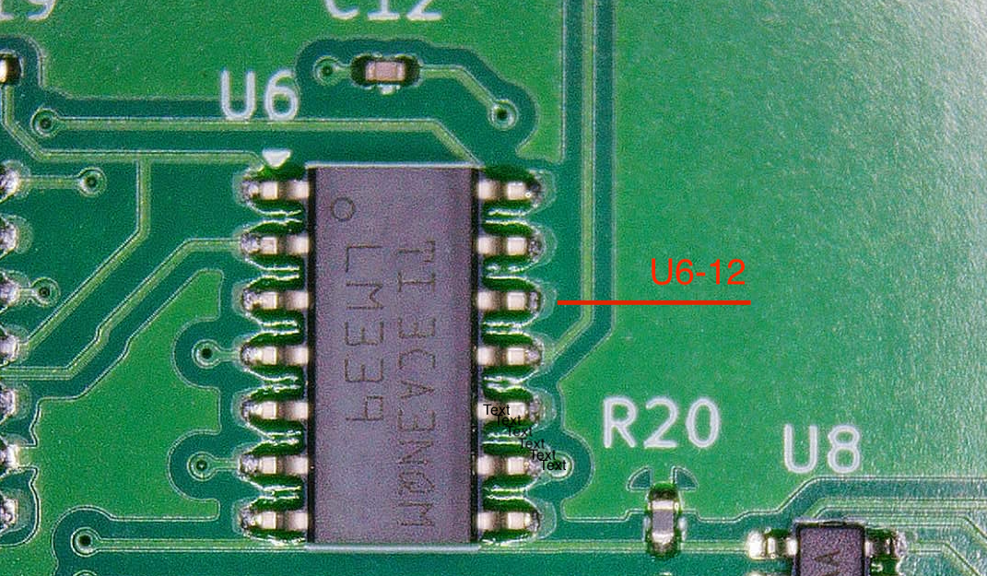 | 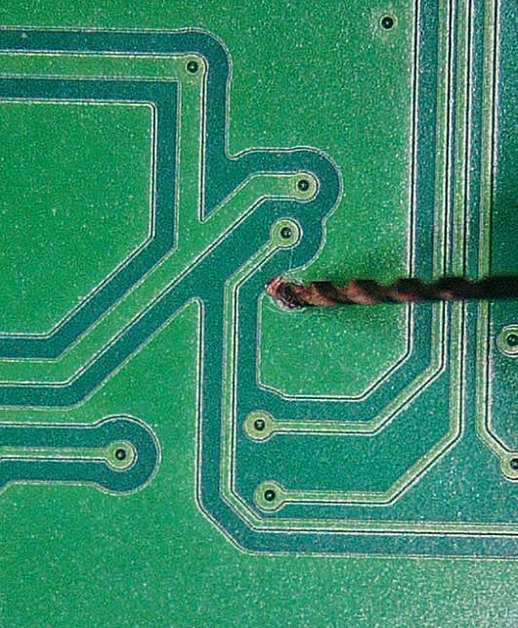 |  | 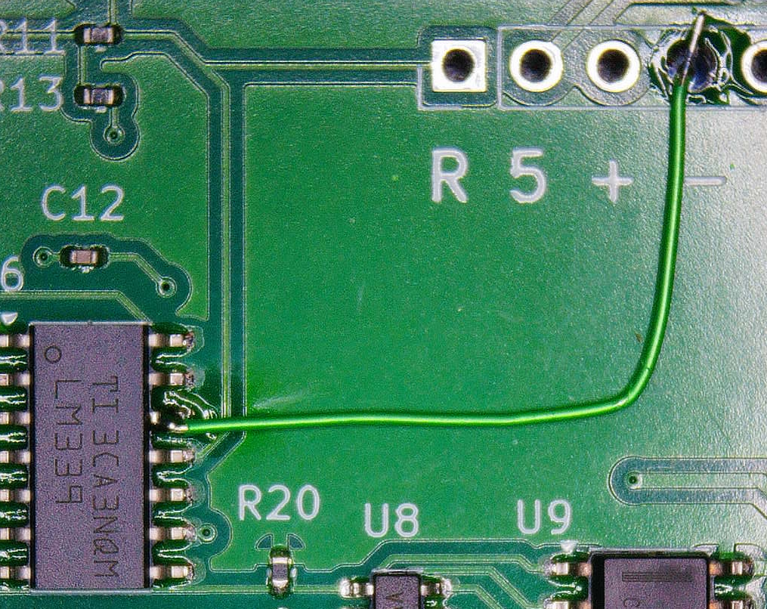
Method 1  Lift pin U6-12  Ensure that there is no solder between the pin and the pad | Method 2  Drill Via below board (Underneath U6)  Verify that U6-12 is not connected to ground (test point G) |  | Jumper U6-12 to test point –  Apply power and verify that U6-12 receives -5Volts when measured from test point G

